VITyarthi | Open Source Software

The Open Source Audit

A Capstone Project for OSS NGMC Course

Course: Open Source Software | Unit Coverage: 1 – 5 Max Marks: 100

Student Name | Registration Number
Abhinav Mishra | 24BSA10067
Slot | Date of Submission
A11 | 27-03-2026

Introduction

Most of the software that powers the modern world — the servers that run websites, the tools that developers use every day, the operating systems inside supercomputers and smartphones
— was not built by a single company and sold for profit. It was built openly, shared freely, and improved collectively. That is the essence of open source.

This project asks you to stop and think about that.

You will choose one real open-source software project — something you can download, read about, and interact with on Linux — and conduct a structured audit of it. Not just 'what does it do,' but why it exists, who built it, what freedoms its license actually gives you, what philosophical values it represents, and how it has shaped the world around it.

Alongside the written report, you will write five shell scripts that demonstrate practical Linux skills. These are not meant to be impressive programs — they are meant to show that you understand how open-source tools work at the command line, and how automation connects to the philosophy of sharing and transparency.
Every line of code you write in your career will sit on top of open-source foundations. Understanding the philosophy behind that is not optional — it is part of being a professional.
Why this matters

Choosing Your Software

Pick one open-source project from the list below, or propose your own (subject to instructor approval). Your choice will be the subject of your entire report and all five shell scripts.

Approved software options

Software | Category | License | Why it's interesting
Linux Kernel | Operating System | GPL v2 | The foundation everything else runs on
Apache HTTP Server | Web Server | Apache 2.0 | Powers ~30% of all websites globally
MySQL | Database | GPL v2 / Commercial | A license with a  dual-model story to tell
Firefox | Web Browser | MPL 2.0 | A nonprofit fighting for an open web
VLC Media Player | Multimedia | LGPL / GPL | Plays anything — built by students in Paris
LibreOffice | Office Suite | MPL 2.0 | Born from a community fork — a real lesson
Python | Programming Language | PSF License | A language shaped entirely by community
Git | Version Control | GPL v2 | The tool Linus built when proprietary failed him
Write your chosen software here before submission: MySQL
Your choice

Project Report Structure

Your report should be 12 to 16 pages long. Each section below maps to a unit in the course. Do not pad with screenshots — every page should contain original thinking and analysis written in your own words.

Part A — Origin and Philosophy (Units 1 & 2)
This is the most important section of the report. Allocate at least four pages to it.

A1. The problem this software was created to solve
Do not just copy the official description. Research the original context. What was frustrating or broken or inaccessible before this software existed? Why did the creator decide to build it and share it rather than keep it proprietary?

Before MySQL in the early 1990s, databases like Oracle and DB2 costs a large amount of money, due to which small developers could not afford it. Michael "Monty" Widenius, David Axmark, and Allan Larsson were working at a company called TcX, they needed a fast, lightweight database. They built MySQL in 1995 in Sweden.

What is your software's origin story? Tell it properly.

MySQL was developed by Michael "Monty" Widenius and David Axmark at the Swedish company in 1995. It was developed to the limited availability of good databases. They created it as a fast, lightweight and open-source alternative to databases of that time. MySQL was ideal for web applications. It was easy to use and was compatible with technologies like PHP. Over time it became the most widely used database in the world. It was then acquired by Sun Microsystems in 2008, it later came under Oracle Corporation in 2010.

A2. The license — what it actually says
Download or find the actual license text for your software. Read it. Then answer these questions in your report:
- What are the four freedoms of free software? Does your software's license grant all four?
Ans) The four freedoms of free software are –
- Freedom 0 - Run the program for any purpose
- Freedom 1 - Study and modify the source code
- Freedom 2 - Redistribute copies
- Freedom 3 - Distribute Modified Version
Yes, MySQL grants all four freedoms.

- Can a company take this software, modify it, and sell it without sharing their changes? Why or why not?
Ans) MySQL has dual licensing which is rare in open source. It means if you distribute modified MySQL, you must release the source code or you must pay Oracle and keep the changes private.

- What is the difference between GPL and MIT licensing? Which would you choose for something you built, and why?
Ans) In GPL sharing changes is allowed but not in MIT licensing. In MIT licensing you can use the software as proprietary software but not in GPL licensing. I will use GPL licensing because it is better if we want to build an open-source software.

- Is there a difference between 'free as in free beer' and 'free as in freedom'? Give an example from your chosen software.
Ans) 'free as in free beer' means it can be downloaded with zero cost and 'free as in freedom' means you have the access to use, modify and share. MySQL is free as in free free beer because you can download it for free and free as in freedom because you have the right to change it’s source code.
Answers copied from Wikipedia or AI tools will score zero. We are looking for your understanding and your words.
Think, don't copy

A3. The ethics of open source
Open source is not just a licensing model — it is a statement about how knowledge and tools should be shared. Reflect on the following:
- Should all software be open source? Make an argument for and against.
Ans) Open-Source software provides transparency and accessibility which allows developers to improve and secure code collectively. However, companies also need to protect their property and maintain competitive edge. That is why I believe there should be a balance between open-source and proprietary software is important.

- Is it ethical for a company to build a profitable product entirely on top of free community labor? (Think about how companies like Red Hat, Google, and Meta use Linux.)
Ans) It can be ethical for companies to make profit from open-source projects like Linux, as long as they obey licenses and contribute back. But if you do not support the community then it is not fair.

- What does 'standing on the shoulders of giants' mean in the context of software? Does open source enable or undermine original innovation?
Ans) The phrase means that you build new technologies by using or improving existing work instead of starting from scratch. Open-source supports this by sharing code and speeding the work flow.

There are no correct answers here. We are grading the depth of your thinking, not your conclusion.

Part B — Linux Footprint (Unit 2)
Research and document how your chosen software lives on a Linux system. Where does it install? What user does it run as? How is it managed? This section requires you to actually install the software on Linux — either on your machine, a virtual machine, or a lab system.

- Installation method — is it available via RPM, apt, or must it be compiled from source?
It is available via apt(query- sudo apt install mysql-server)
- Key directories — where are its binaries, config files, and logs stored? (e.g., /usr/bin,
/etc, /var/log)
These files are stored in the root filesystem(/)
- User and group — what Linux user and group does it run under? Why does this matter for security?
MySQL on Linux typically runs under the mysql user and mysql group.
- Service management — can it be started, stopped, or restarted as a service? Show the commands.
Yes, it can be started, stopped, or restarted and the commands are –
- Start - sudo systemct1 start mysql
- Stop - sudo systemct1 stop mysql
- Restart - sudo systemct1 restart mysql
- Update model — how does the open-source community push security patches to your machine?
Updates come through your linux distributer. Developers find and fix bugs in mysql and added to official releases. Your linux distro packages these updates and you receive this via package manager.

Part C — The FOSS Ecosystem (Units 3 & 4)
No open-source project exists in isolation. Map the ecosystem around your chosen software.

- What other open-source tools does it depend on? (Libraries, compilers, runtimes)
Ans) It depends on –
- Linux - for OS support
- OpenSSL - for handling encryption library
- GCC - Source code compiler
- What has it enabled or inspired? (Forks, spin-offs, tools built on top of it)
Forks - MariaDB, Percona Server
Tools built on top of it – phpMyAdmin, MySQL Workbench
- Where does it fit in the LAMP stack, or how does it relate to the web?
It is used to maintain database of the website.
- Is there a community — mailing lists, forums, conferences, IRC channels? Who governs it?
MySQL is mainly governed by Oracle Corporation

Part D — Open Source vs Proprietary (Critical Analysis)
Compare your chosen software against its closest proprietary alternative. Be specific and honest
— do not assume open source is always better.

Dimension | Open Source | Proprietary Alternative
Cost | free | Expensive
Security (who can audit the code?) | Anyone can audit | Only company engineers can audit
Support and reliability | Community support | Official support team
Freedom to modify | Anyone can modify | No freedom to modify

Community vs corporate control | Large global community | Fully corporate
Your overall verdict | Best for startups, web applications | Best for large enterprises

Fill in the table as part of your report, then write a two-paragraph conclusion: given everything you have learned, would you recommend your chosen software for a real-world deployment? Would you contribute to it?
Ans) I recommend MySQL for real-world deployment, especially for startups, web applications and for budget-conscious projects. It’s low cost, flexible and easy to use. It can be used in web applications to maintain database.
Yes, I would be eager to contribute to MySQL. This not only helps to improve the software but will also build practical skills.

Shell Script Tasks

You will write five shell scripts. Each script must be submitted as a plain .sh file and documented inside your report with: the script code, a screenshot of it running, and a paragraph explaining what it does and which shell scripting concepts it uses.
Scripts must run on a real Linux system. They must include comments explaining each section. Uncommented scripts will lose marks.
Important

Script 1 — System Identity Report (Unit 1 & 2)
Write a script that introduces the Linux system like a welcome screen. It should display:
  - The Linux distribution name and kernel version
  - The current logged-in user and their home directory
  - System uptime and current date/time
  - A message stating which open-source license covers the OS

Concepts to use: variables, echo, command substitution ($()), basic output formatting.

Starter structure
#!/bin/bash
# Script 1: System Identity Report
# Author: [Your Name] | Course: Open Source Software
# --- Variables --- STUDENT_NAME=""
SOFTWARE_CHOICE=""
# Fill in your name
# Fill in your chosen software
# --- System info --- KERNEL=$(uname -r) USER_NAME=$(whoami) UPTIME=$(uptime -p)

# --- Display ---
echo "================================"
echo " Open Source Audit — $STUDENT_NAME" echo "================================"
echo "Kernel : $KERNEL" echo "User : $USER_NAME" echo "Uptime : $UPTIME"
# TODO: Add distro name, date, and license message

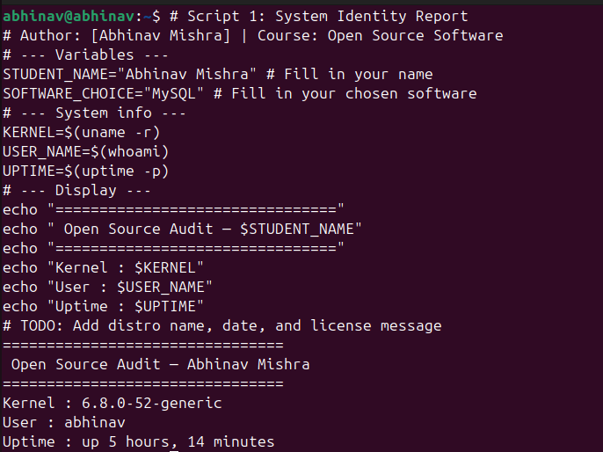

Script 2 — FOSS Package Inspector (Unit 2)
Write a script that checks whether your chosen software is installed on the system, finds its version, and uses a case statement to print a short description of its purpose based on the package name.

Concepts to use: if-then-else, case statement, rpm -qi or dpkg -l, pipe with grep.

Starter structure
#!/bin/bash
# Script 2: FOSS Package Inspector
PACKAGE="" # e.g. httpd, mysql, vlc, firefox # Check if package is installed
if rpm -q $PACKAGE &>/dev/null; then echo "$PACKAGE is installed."
rpm -qi $PACKAGE | grep -E 'Version|License|Summary' else
echo "$PACKAGE is NOT installed."
fi

# TODO: Add a case statement that prints a one-line
# philosophy note about the package based on its name case $PACKAGE in
httpd) echo "Apache: the web server that built the open internet" ;; mysql) echo "MySQL: open source at the heart of millions of apps" ;; # TODO: Add your software and 3 others
esac

Script 3 — Disk and Permission Auditor (Unit 2)
Write a script that loops through a list of important system directories and reports: how much space each uses, and the owner and permissions of the directory. Use a for loop.

Concepts to use: for loop, df, ls -ld, awk or cut to extract fields.

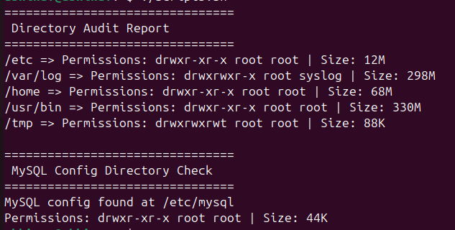
Starter structure
echo "$DIR does not exist on this system"
fi done

# TODO: Add a section that checks if your software's # config directory exists and prints its permissions
#!/bin/bash
# Script 3: Disk and Permission Auditor DIRS=("/etc" "/var/log" "/home" "/usr/bin" "/tmp")
echo "Directory Audit Report" echo " "

for DIR in "${DIRS[@]}"; do
if [ -d "$DIR" ]; then
PERMS=$(ls -ld $DIR | awk '{print $1, $3, $4}') SIZE=$(du -sh $DIR 2>/dev/null | cut -f1)
echo "$DIR => Permissions: $PERMS | Size: $SIZE" else

Script 4 — Log File Analyzer (Units 2 & 5)
Write a script that reads a log file line by line, counts how many lines contain a keyword (like ERROR or WARNING), and prints a summary. Use a while-read loop and an if-then inside it.

Concepts to use: while read loop, if-then, counter variables, command-line arguments ($1).

Starter structure
#!/bin/bash
# Script 4: Log File Analyzer
# Usage: ./log_analyzer.sh /var/log/messages
LOGFILE=$1 KEYWORD=${2:-"error"}
COUNT=0
# Default keyword is 'error'
if [ ! -f "$LOGFILE" ]; then
echo "Error: File $LOGFILE not found." exit 1
fi

while IFS= read -r LINE; do
if echo "$LINE" | grep -iq "$KEYWORD"; then COUNT=$((COUNT + 1))
fi
done < "$LOGFILE"

echo "Keyword '$KEYWORD' found $COUNT times in $LOGFILE"

# TODO: Add a do-while style retry if the file is empty, # and print the last 5 matching lines using tail + grep

Script 5 — The Open Source Manifesto Generator (Unit 5)
This is the most creative script. Write a script that generates a personalised open source philosophy statement by asking the user three questions interactively, then composing a short paragraph using their answers and saving it to a .txt file.

Concepts to use: read for user input, string concatenation, writing to a file with >, date command, aliases concept demonstrated via a comment.

Starter structure
#!/bin/bash
# Script 5: Open Source Manifesto Generator

echo "Answer three questions to generate your manifesto." echo ""

read -p "1. Name one open-source tool you use every day: " TOOL read -p "2. In one word, what does 'freedom' mean to you? " FREEDOM
read -p "3. Name one thing you would build and share freely: " BUILD

DATE=$(date '+%d %B %Y')
OUTPUT="manifesto_$(whoami).txt"

# TODO: Compose a paragraph using $TOOL, $FREEDOM, $BUILD # and write it to $OUTPUT using echo and >>

echo "Manifesto saved to $OUTPUT" cat $OUTPUT

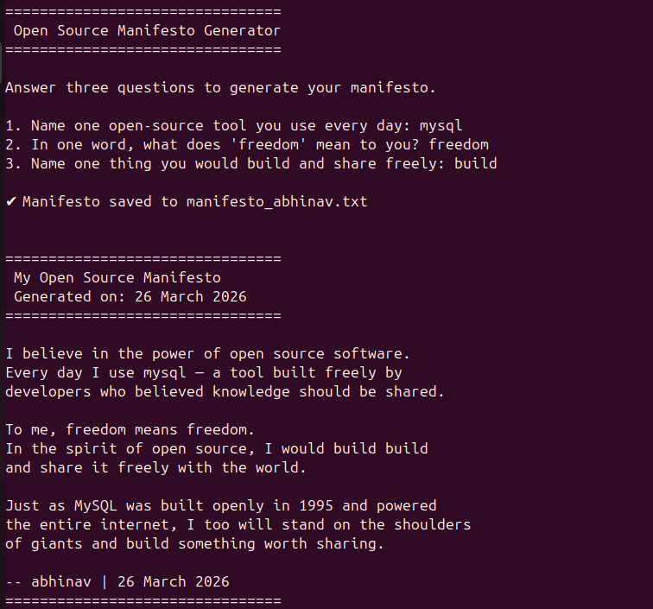

Project Timeline

This timeline is a guide, not a rigid rule. Some students will move faster on the technical parts; others will spend more time on the philosophical sections. Adjust based on your strengths — but do not leave the scripts to the final stretch.

Day | Focus | Tasks | Deliverable
1 | Setup | Choose software. Research its origin story. Read the license text. Set up your Linux environment (VM or lab system). Install your chosen software. | Choice confirmed
2 | Philosophy | Write Part A1 — the origin story. Take notes on what problem the software solved and for whom. | Draft A1
3 | License & Ethics | Write Part A2 — license analysis. Write Part A3  — ethical reflection. These sections need your own thinking, not summaries. | Draft A2 + A3
4 | Linux Footprint | Install software on Linux. Document directories, user, permissions. Write Part B. | Draft Part B + screenshots
5 | Scripts 1 & 2 | Write and test Script 1 (System Identity) and Script 2 (Package Inspector). Add them to your report with explanations. | Scripts 1–2 working
6 | Scripts 3 & 4 | Write and test Script 3 (Disk Auditor) and Script 4 (Log Analyzer). Test with a real log file. | Scripts 3–4 working
7 | Ecosystem | Write Part C — FOSS ecosystem map. Research dependencies and community. | Draft Part C
8 | Comparison & Script 5 | Write Part D — comparison table and verdict. Write and test Script 5 (Manifesto Generator). | Draft Part D + Script 5
9 | Report polish | Compile full report. Write introduction and conclusion. Add screenshots. Check page count (12–16 pages). | Complete draft
10 | Submission | Final review. Submit report + 5 .sh files. Be ready to explain any script in a short viva if asked. | Final submission

Evaluation Rubric

Total marks: 100. The report carries 60 marks and the shell scripts carry 40 marks. There is no viva unless the evaluator suspects the work is not original — in which case any student may be called for a brief oral explanation.

Report (60 marks)

# | Component | Full marks | Passing (50%) | Notes
1 | Origin story — depth, original research, storytelling | 12 | 6 | Part A1
2 | License analysis — accuracy and understanding of freedoms | 12 | 6 | Part A2
3 | Ethical reflection — quality of argument and original thinking | 10 | 5 | Part A3
4 | Linux footprint — technical accuracy and screenshots | 10 | 5 | Part B
5 | Ecosystem and LAMP connection | 8 | 4 | Part C
6 | Open source vs proprietary comparison | 8 | 4 | Part D

Shell Scripts (40 marks — 8 marks each)
Each script is marked on three criteria:

Criterion | Marks | What we look for
Correctness — does it run without errors? | 4 | Script executes on Linux and produces expected output
Concepts — does it use the right shell constructs? | 2 | Loops, if-then, case, variables used appropriately for the task
Comments and documentation | 2 | Every non-obvious line has a comment; script purpose is clear
All written sections must be in your own words. Code that is copy-pasted from the internet without understanding will be zero-marked. Running a script and explaining what it does in a conversation is considered a passing demonstration of understanding.
Academi c integrity

Reference Resources

Use these as starting points, not as sources to copy from. The report must be in your own words.

On open source philosophy
  - GNU Project — 'The Free Software Definition': gnu.org/philosophy/free-sw.html
  - Open Source Initiative — 'The Open Source Definition': opensource.org/osd
  - Eric S. Raymond — 'The Cathedral and the Bazaar': catb.org/~esr/writings/cathedral-bazaar
  - Linus Torvalds — 'Just for Fun' (autobiography, available at most libraries)

On Linux and shell scripting
  - The Linux Command Line by William Shotts — freely available at linuxcommand.org
  - GNU Bash Manual: gnu.org/software/bash/manual
  - Linux man pages: man.cx (online) or type 'man <command>' in your terminal

For finding license texts
  - SPDX License List: spdx.org/licenses
  - Choose a License: choosealicense.com
  - Your software's official repository on GitHub or GitLab — the LICENSE file is always there

A closing thought
Every tool you will use in your career — the editor, the compiler, the server, the database — was shaped by people who chose to build in the open and share their work freely. Understanding why they made that choice, and what it means for the world, is not a footnote to your technical education. It is the foundation of it.

Submission Requirements

All submissions are made through the VITyarthi portal. You must submit three things: a public GitHub repository link, a README.md inside the repository, and a project report PDF. All three are compulsory. Incomplete submissions will not be evaluated.

What to submit on the VITyarthi portal

Item | Details | Compulsory?
GitHub repo link | The repository must be public. It must contain all five .sh script files and a README.md. Name the repo:  oss-audit-[rollnumber] | Yes
README.md | Must be inside the GitHub repository. Must include: student name and roll number, chosen software, description of each script, step-by-step instructions to run each script on Linux, and any dependencies required. | Yes

Project report PDF | Upload directly on the VITyarthi portal. Must follow the structure in Section 3. Must be 12 to 16 pages. Must be your own writing. | Yes
On the VITyarthi portal submission form, paste the GitHub repository URL, confirm the README is present in the repository, and upload the project report PDF. All three must be submitted together in a single submission — partial submissions will not be accepted.

Evaluation pipeline
Every submission goes through an automated evaluation pipeline before it reaches an evaluator. Be aware of the following checks that run on every submitted report and script set.

Check | What it detects | Consequence
Plagiarism detection | Report text copied from websites, Wikipedia, other students’ submissions, or any published source without attribution. Cross-submission similarity between enrolled students is also flagged. | Zero on the full report. Referred to disciplinary committee if similarity exceeds 40%.
AI generation detection | Report sections generated by AI tools such as ChatGPT, Gemini, Claude, or similar. The pipeline checks for linguistic patterns, sentence uniformity, and structural signatures common to AI-generated text. | Flagged submissions are called for a mandatory viva. If the student cannot explain the content, zero marks are awarded.
A note on AI tools: you may use AI to understand concepts, debug scripts, or get explanations. You may not use AI to write your report. The distinction is the same as using a calculator versus asking someone else to sit your exam. The report must reflect your thinking, your words, and your conclusions.

